**TEAM ASSIGNMENT 12**

**REPORT.**

1. Introduction.

We classify the question into 6 criteria.

|  |  |  |
| --- | --- | --- |
| Criteria | Description | Question number |
| Work Environment. | Rooms, equipment, organization, comfort on the job. | 2,4,5,6,10,12 |
| Communication. | Communication in relationships, relation between people with each others, employees with boss. | 9 |
| Chance. | Be treated fairly, with learning opportunities, promotion | 1,3,15 |
| Job security. | Stable work, comfortable working, long-term | 7,11 |
| Democratization. | Is owned the work, democracy, suggesting and be respected | 8,13,14 |
| Morale. | The interest of staff | 16 |

1. Overall assessment.

*Picture above describe satisfaction rates in work of employees in 2 years with 3 index. Positive (satisfied), neutral and negative (unsatisfied ).*

* In 2 years. The employees are satisfied with their work but rate is not high and it tends to decrease.
* Unsatisfied rate in 2010 is higher than 2009.
* The employees feel ambiguous in their work are increase.
* This is not good with satisfied rate is low and decreasing in future.

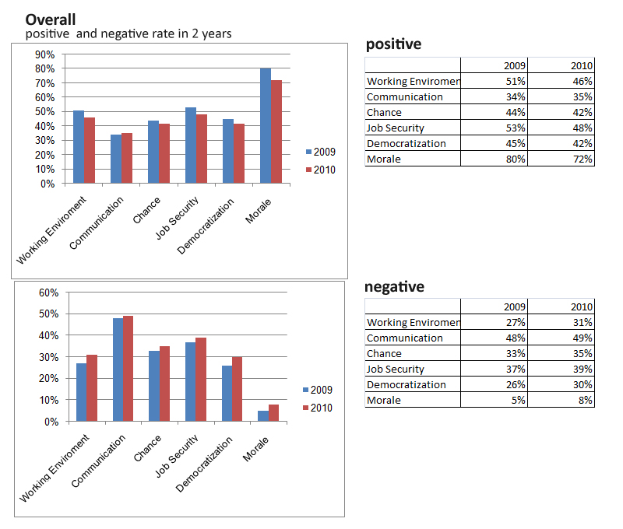

*Picture above describe satisfaction rates in work of employees in 2 years with 6 criteria in 2 years with 2 index. Positive (satisfied) and negative (unsatisfied ).*

* In all criteria, positive rate is decreasing and negative is increasing.
* This is not good for future.
* Working environment, communication, chance, job security and democratization are not satisfied the employees with low positive rate.

1. Detailed assessment

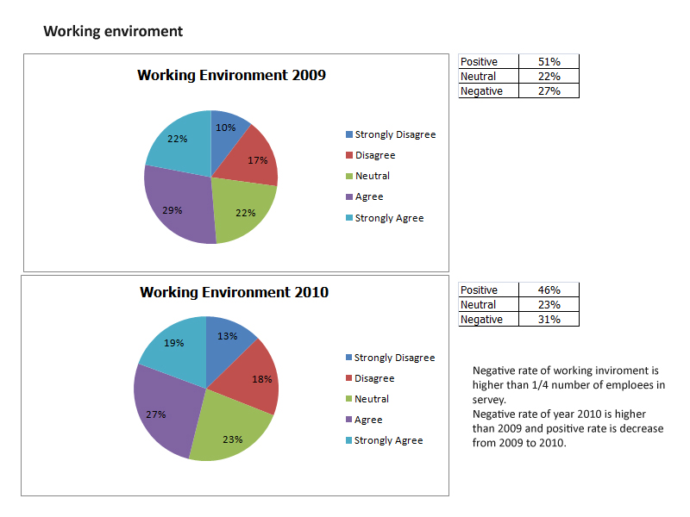

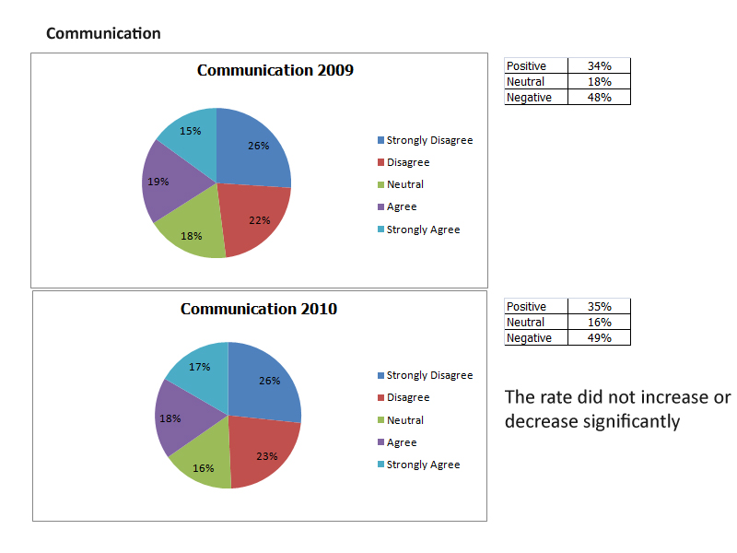

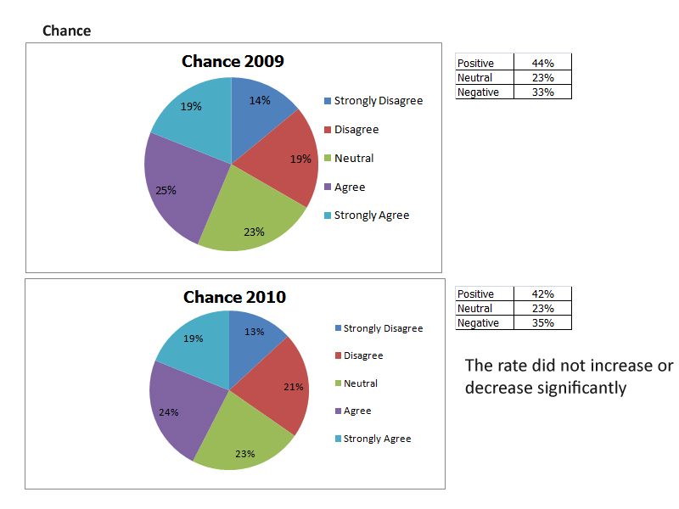

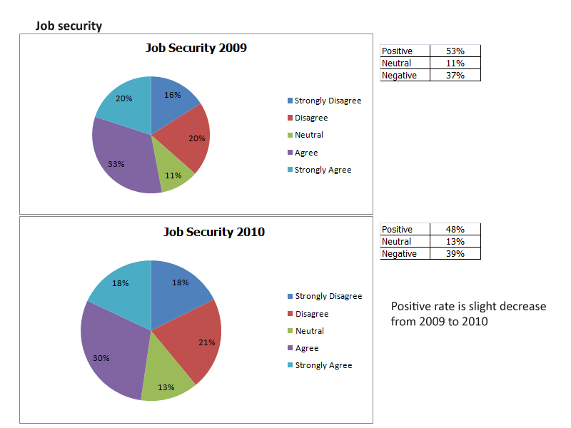

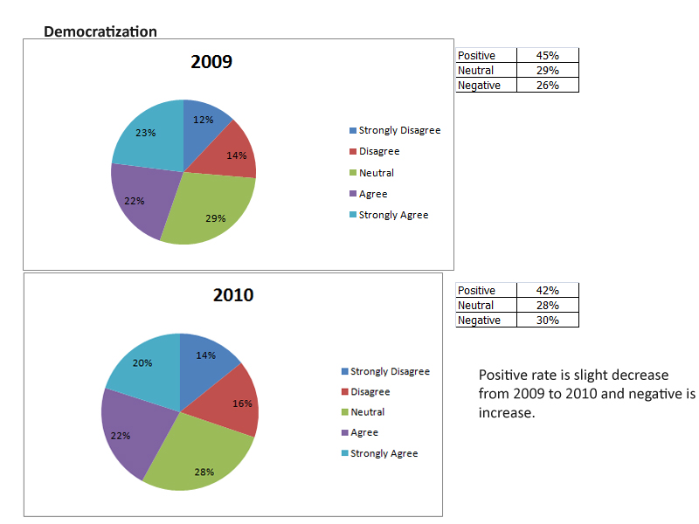

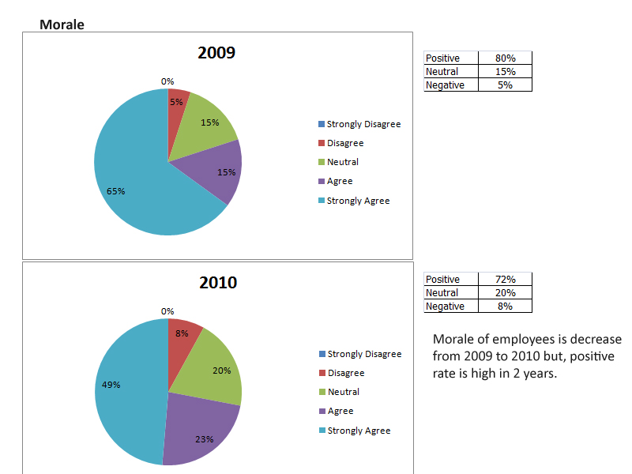

1. Recommend.

For survey.

* Should add a section below each question for survey participants to write their comment of this question.
* Should add some questions about health, entertainment .. in survey.

For company.

* The satisfaction of employees in company are low, less than 50% and decreasing in future but morale is high.
* The neutral rate is increasing and at high threshold >20%.
* The management should find out their employees carefully, begin by asking the area with high neutral rate in company to see what they need, what they want and their desired.
* Find out and improve working environment, communication, chance to increase satisfaction. Focus on communication.
* Morale is high but is decreasing, management should give solution to keep it high and increase in future.